

**Diabetes Predictor**

Presented by: Submitted to:

Siddhant Kaushik (10717210049) Dr. Puneet Goswami sir

Yash Saraf (10717210056)

Sarthak Seth (10717210045)

**DECLARATION**

We, the undersigned declare that the work embodied in this project work hereby, titled **“Diabetes Predictor”**, forms our own contribution to the research work carried out under the guidance of **“Dr. Puneet Goswami sir”** is a result of our own research work and has not been previously submitted to any other University for any other Degree/ Diploma to this or any other University.

**Acknowledgement**

I express my sincere gratitude to my colleagues for their guidance, continuous support and cooperation throughout the preparation process of the project, without which the present work would not have been possible.

I would also like to give special thanks to Dr. Puneet Goswami , for the guidance that they provided throughout the project. I shall be failing in my works if I didn’t convey my thanks to class teachers, who provided me all the thoughts and insights.

A special word of thanks to all the respondents for sharing their valuable time with me.

**Table of content**

Aim & Objective -----------------------------🡪 5

About The Project ----------------------------🡪 6

Problem Statement ---------------------------🡪 6

Technologies Used ---------------------------🡪 7

Codes & Snapshots --------------------------🡪 9

Result ------------------------------------------🡪 12

**Aim & Objectives**

Aim: To develop a web application which can be easily used for prediction whether a lady is suffering with diabetes or not.

Objective:

1. To create web application using HTML & CSS
2. Use Machine Learning for prediction of diabetes
3. Flask which could provide an API to connect web page and Machine Learning model.

**About The Project**

It is a web application project which is used to predict weather a women in suffering from diabetes of not. We have used a PIMA diabetes data set from kaggle which consists of 2000 rows and 9 columns. We have used machine learning algorithm to create a model which will predict weather a person have diabetes or not. Then used HTML (Hypertext Transfer Protocol) which is used for creating for a web page.CSS (Cascading style sheet) is used for designing the web page. Web page is a front-end which is directly accessible by the user and machine learning is the back-end which is used for future prediction but the Flask is used for connecting both. Flak provide API which links both front-end and back-end.

**problem Statement**

‘**Prediction of Females suffering from Diabetes’**

**Technologies Used**

**Random Forest Classifier:**Random forests is a supervised learning algorithm. It can be used both for classification and regression. It is also the most flexible and easy to use algorithm. Random forests creates decision trees on randomly selected data samples, gets prediction from each tree and selects the best solution by means of voting. It also provides a pretty good indicator of the feature importance.Random forests has a variety of applications, such as recommendation engines, image classification and feature selection. It can be used to classify loyal loan applicants, identify fraudulent activity and predict diseases. It lies at the base of the Boruta algorithm, which selects important features in a dataset.

It works in four steps:

1. Select random samples from a given dataset.
2. Construct a decision tree for each sample and get a prediction result from each decision tree.
3. Perform a vote for each predicted result.
4. Select the prediction result with the most votes as the final prediction.

Random Forest doesn’t suffer from the overfitting problem. The main reason is that it takes the average of all the predictions, which cancels out the biases.

**Flask:** Flask is a popular Python web framework, meaning it is a third-party Python library used for developing web applications.Flask’s framework is more explicit than Django’s framework and is also easier to learn because it has less base code to implement a simple web-Application. A Web-Application Framework or Web Framework is the collection of modules and libraries that helps the developer to write applications without writing the low-level codes such as protocols, thread management, etc. Flask also has a built-in development server and fast debugger.

**Pickle:** The Python pickle module is another way to serialize and deserialize objects in Python. It differs from the json module in that it serializes objects in a binary format, which means the result is not human readable. However, it’s also faster and it works with many more Python types right out of the box, including your custom-defined objects. Pickling is a way to convert a python object (list, dict, etc.) into a character stream. The idea is that this character stream contains all the information necessary to reconstruct the object in another python script.

**Snapshots**

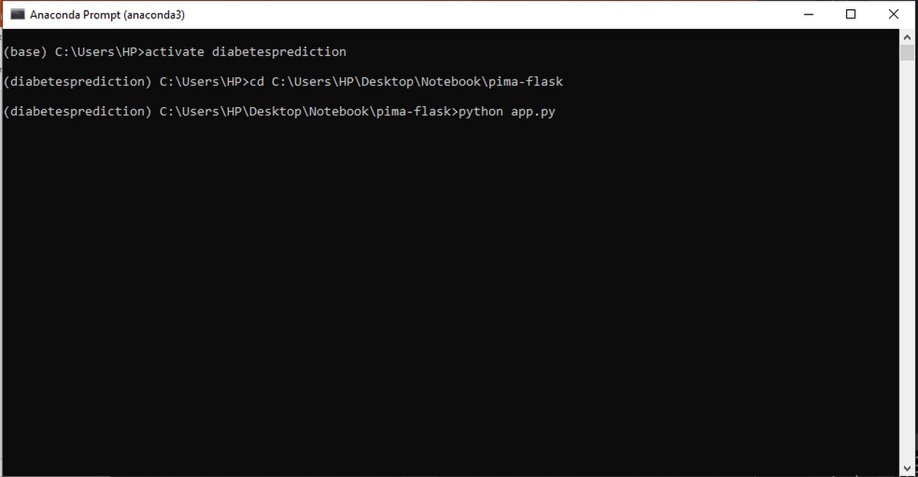

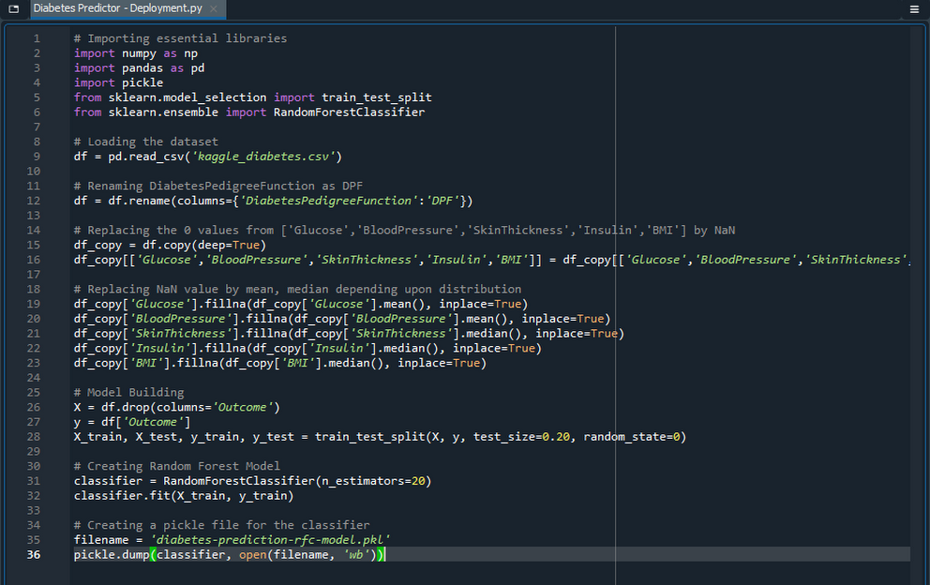

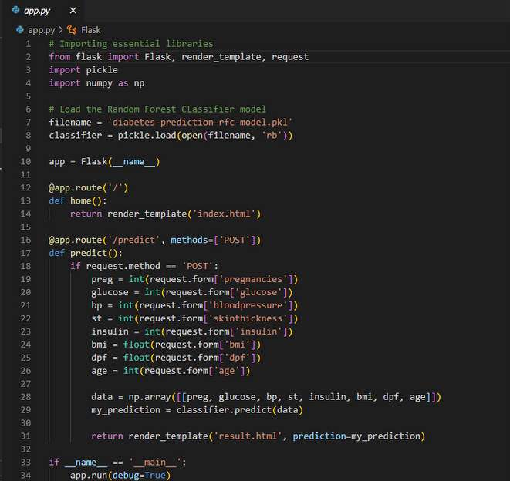

Result

